

**UNIVERSITY OF PETROLEUM & ENERGY STUDIES**

**Dehradun**

**CONTINOUS INTEGRATION**

**AND**

**CONTINOUS DELIVERY**

**Experiment**

**Name: Rithik Choudhary**

**Course: B. TECH CSE DevOps (2018-22)**

**Roll no.: R171218084**

**Sapid: 500069261**

**Experiment-1**

**Installation of Jenkins**

***To install jenkins in linux system***

***Step 1– We need to install java in linux system by using the below commands***

**>sudo apt install default-java**

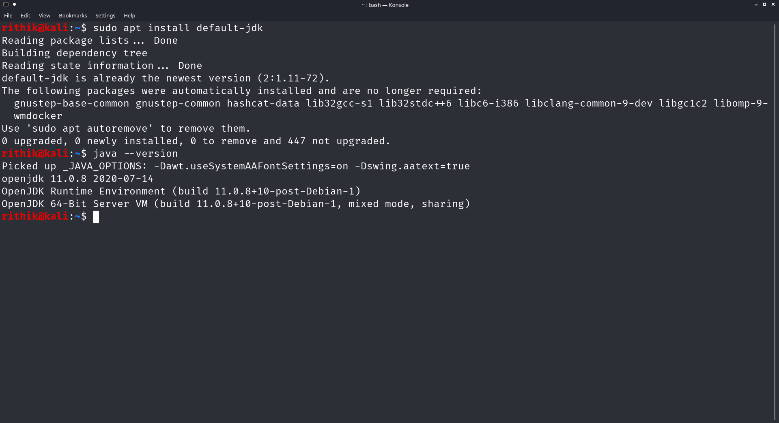

## ***Step 2- Add the Jenkins Repository***

## **After installing java we have define the path and the key from where the terminal will capture the data or jenkins binary file to download or install**

**>wget –q –O - https://pkg.jenkins.io/debian/jenkins.io.key | sudo apt-key add –**

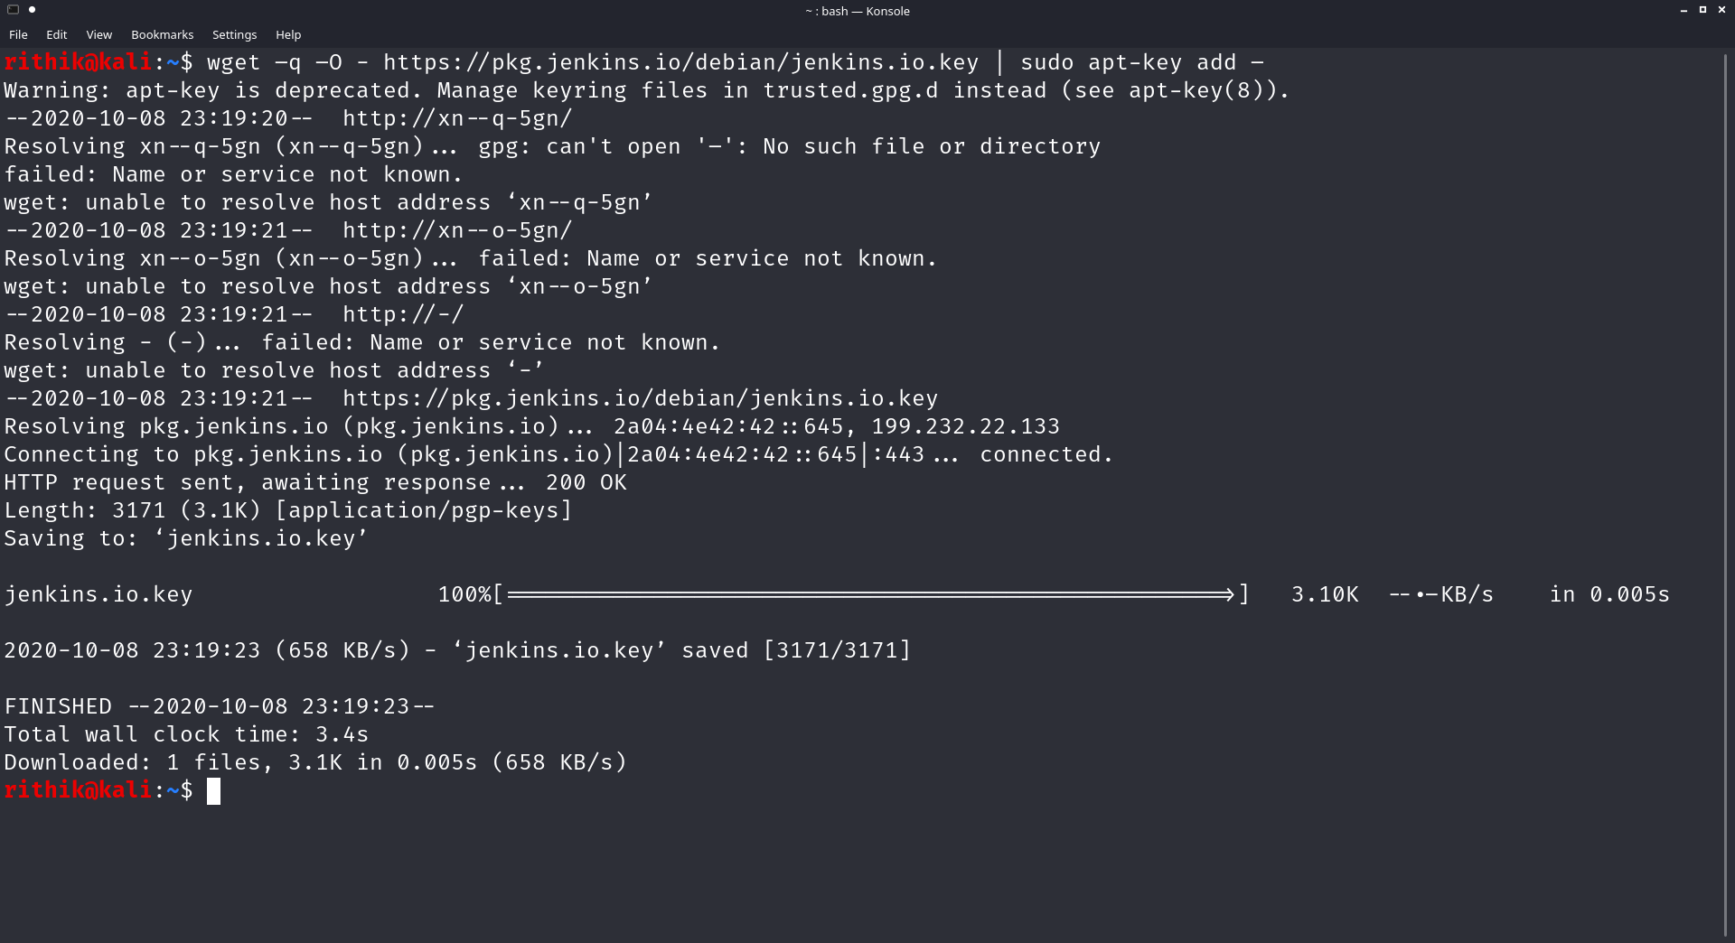

## *Step 3: Install Jenkins*

**First we have to update the path defined in *etc*/apt/sources.list by the above command**

**So to update the path we will use this command.**

**>sudo apt update**

**Now to install jenkins we use the below command.**

**>sudo apt install jenkins**

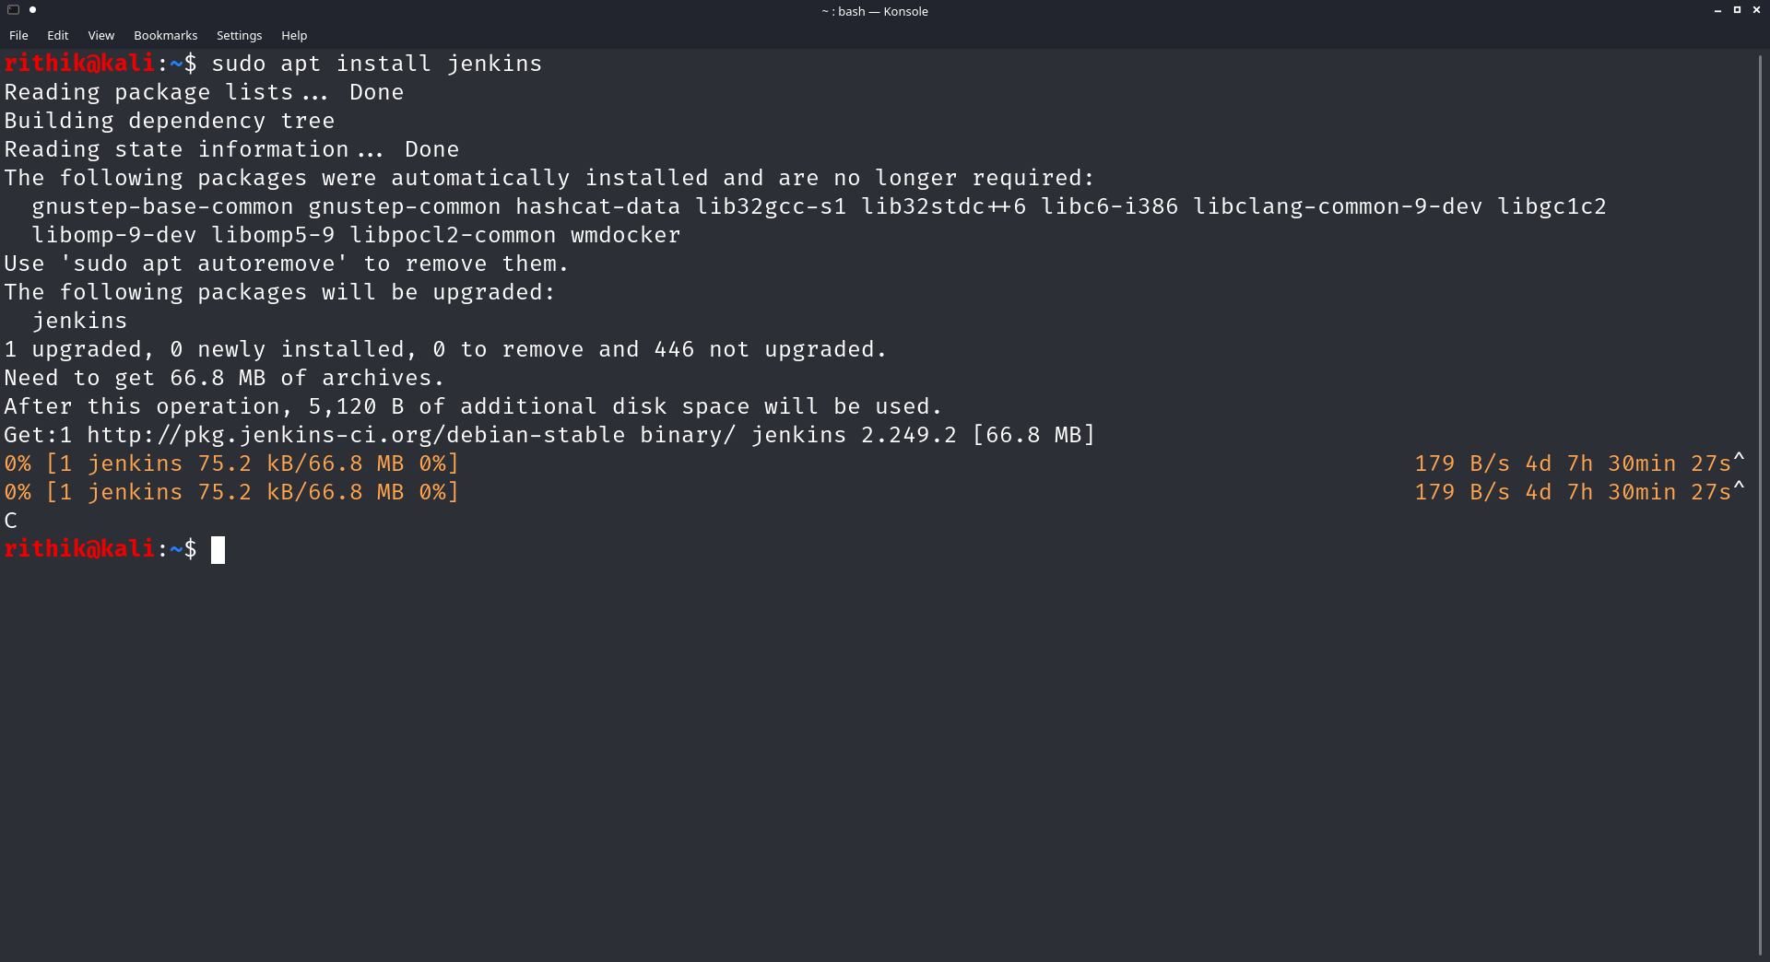

**In the above picture the jenkins installation started, i have to stop that beacuse i have already installed it**

## ***Step 4: Modify Firewall to Allow Jenkins***

**You need to open Port 8080 to allow Jenkins to communicate.**

**If you’re using the default UFW firewall, enter the following:**

**>sudo ufw allow 8080**

**>sudo ufw status**

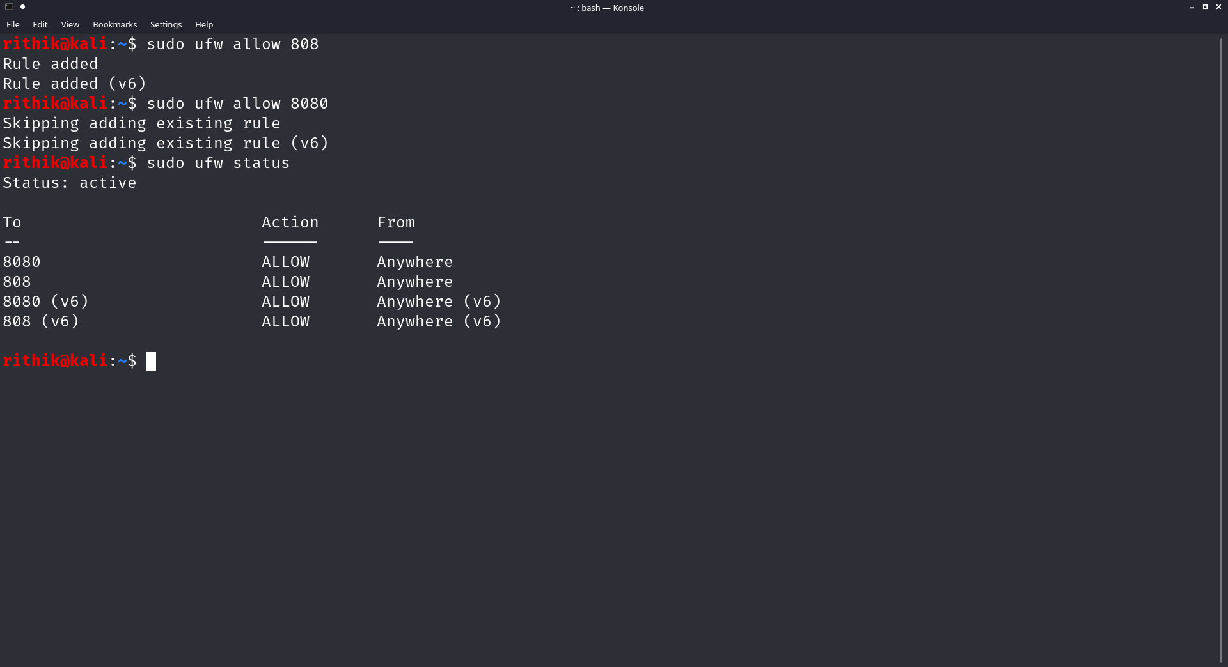

**If you’re using a different firewall application, follow its specific instructions to allow traffic on Port 8080.**

**In the default UFW, if you haven’t configured the firewall it displays as inactive. You can** [**enable UFW**](https://phoenixnap.com/kb/how-to-enable-disable-firewall-ubuntu) **using the following:**

**>sudo ufw enable**

## ***Step 5: Set up Jenkins***

**To launch and set up Jenkins, open a web browser, and navigate to the IP address of your server:**

**http://ip_address_or_domain:8080**

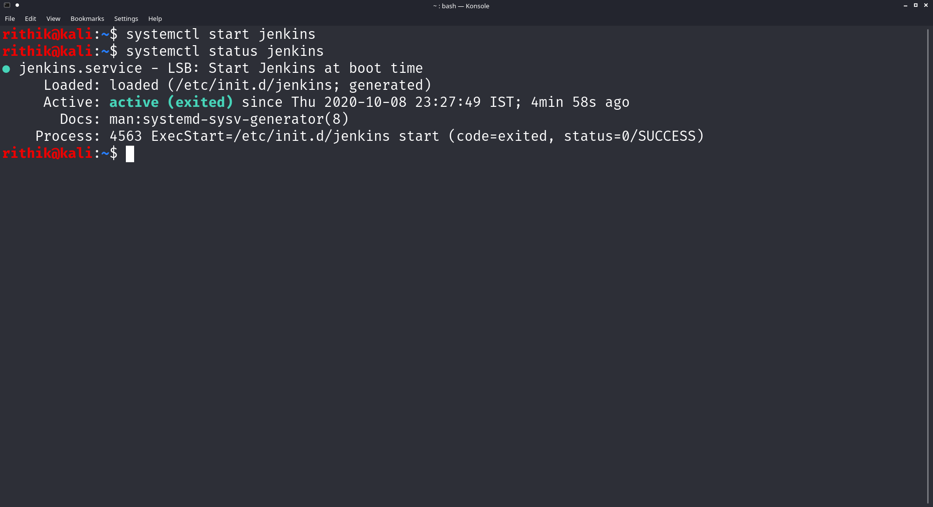

**Use the actual IP address or domain name for the server you’re using Jenkins on.**

**You should see a page that prompts you to Unlock Jenkins. You’ll need the default password. You can get the default password by switching to a command line and entering the following:**

**sudo cat /var/lib/jenkins/secrets/initialAdminPassword**

**The system returns an alphanumeric code. Enter that code, then click Continue.**

**Next, you are prompted to either Install suggested plugins or Select plugins to install. It’s fine to simply install the suggested plugins. You can always install more plugins later. The system continues the initial Jenkins setup.**

**Then you will be prompted to Create First Admin User. Enter the credentials you want to use for your Jenkins administrator, then Save and Continue.**

**After this, you should set up the Instance Configuration. This is the preferred network address for this Jenkins installation. Confirm the address you want to use for your server. This is most likely the same address you used to get to this configuration page. When you’re satisfied, click Save and Finish.**

**You should see a page that says Jenkins is ready! You can click Start using Jenkins to open the Jenkins dashboard.**

